 

**STUDENT NAME:** VINITHAA SINGH D

# SEAT NO: 16

**PROJECT ID:** 16

**PROJECT TITLE:** HOSTEL

|  |  |
| --- | --- |
| **TECHNICAL COMPONENTS** | **TECH STACK** |
| BACKEND | **Node.js with Express.js** |
| FRONTEND | **React.js** |
| DATABASE | **Mongo DB (No-SQL)** |
| API | **Open API** |

# PROBLEM STATEMENT:

1. The existing hostel management relies on inefficient manual processes such as room allocation, fee management, and attendance tracking, which are time-consuming and prone to errors.
2. A digital solution is necessary to automate and streamline these administrative tasks, reducing operational challenges.
3. This solution should provide an intuitive platform for administrators to manage hostel operations effectively and offer students easy access to essential services like room selection and leave management.
4. By digitizing and centralizing hostel management processes, the system will enhance efficiency, accuracy, and transparency, improving the hostel experience for both administrators and students.

# PROJECT-FLOW:

1. PURPOSE:

* The purpose of the project is to digitize and centralize hostel management processes to streamline administrative tasks such as room allocation, fee management, and attendance tracking.

1. SCOPE:

* The scope includes developing an intuitive dashboard for administrators to manage hostel operations efficiently.
* Implementing a student portal to provide convenient access to essential services like room selection, leave management, and attendance tracking.

1. BUSINESS CONTEXT:

* Integrating a database system to store and manage student records, room allocations, fee payments, and attendance data.
* Developing a communication module for sending notifications and announcements to students and staff.

1. CONSIDERATIONS:

* Ensuring a user-friendly interface for both administrators and students to navigate and interact with the system seamlessly.
* Implementing robust security measures to protect sensitive information stored within the system and ensuring compliance with data protection regulations.

1. USER PERSONANS:

* The administrator persona represents hostel administrators responsible for managing hostel operations, overseeing room allocations, fee management, and generating reports.
* The student persona represents hostel residents who need access to essential services such as room selection, leave management, attendance tracking, and receiving notifications and announcements.

1. USER STORIES:

* As an administrator, I want to have access to an intuitive dashboard where I can efficiently manage room allocations, track fee payments, and generate reports to streamline hostel operations.
* As a student, I want to access a user-friendly portal where I can easily select my room, apply for leave, track my attendance, and receive important notifications and announcements from hostel management.

# PROJECT FEATURES:

## User Authentication:

* Secure login system for both administrators and students.
* Support for traditional email/password login as well as OAuth login using services like Google.

## Admin Dashboard:

* Comprehensive dashboard displaying key information and statistics.
* Access to various management functionalities like hostel blocks, rooms, fees, students, reports, etc.

## Hostel Management:

* Ability to manage hostel blocks, including adding, editing, and deleting blocks.
* Room management functionalities such as viewing room details, allocating rooms, updating room status, etc.
* Fee management to track student fee payment; manage fee structure, and categories.

## Student Management:

* View student details including their room assignments, contact information, etc.
* Approve/reject student applications, if students apply separately.
* Manage student attendance records, leave applications, and complaints/feedback.

## Attendance Management:

* Attendance tracking system for students residing in the hostel.
* Record and manage attendance data, including late attendance instances.

## Leave Management:

* Allow students to submit leave applications specifying dates and reasons for absence.
* Admin approval/rejection of leave applications.
* Automatic cancellation of leave if a student enters the hostel during the leave period.

## Complaints and Feedback:

* Provide a platform for students to submit complaints regarding hostel facilities or services.
* Admin review and response to student complaints within the system. Collect and utilize student feedback for improvement.

## Reports Generation:

* Generate various reports on hostel occupancy, room-wise occupancy, fee collection, attendance records, leave applications, etc.
* Download or print reports for further analysis and decision-making.

## Messaging System:

* Access a messaging module to send notifications to students or parents regarding attendance, hostel announcements, leave application updates, etc.

## Optional Features:

* Guest management functionalities for managing guest visits by students.
* Inventory management to track and manage hostel inventory.
* Security deposit management for managing security deposits collected from students.

# FLOWCHART:

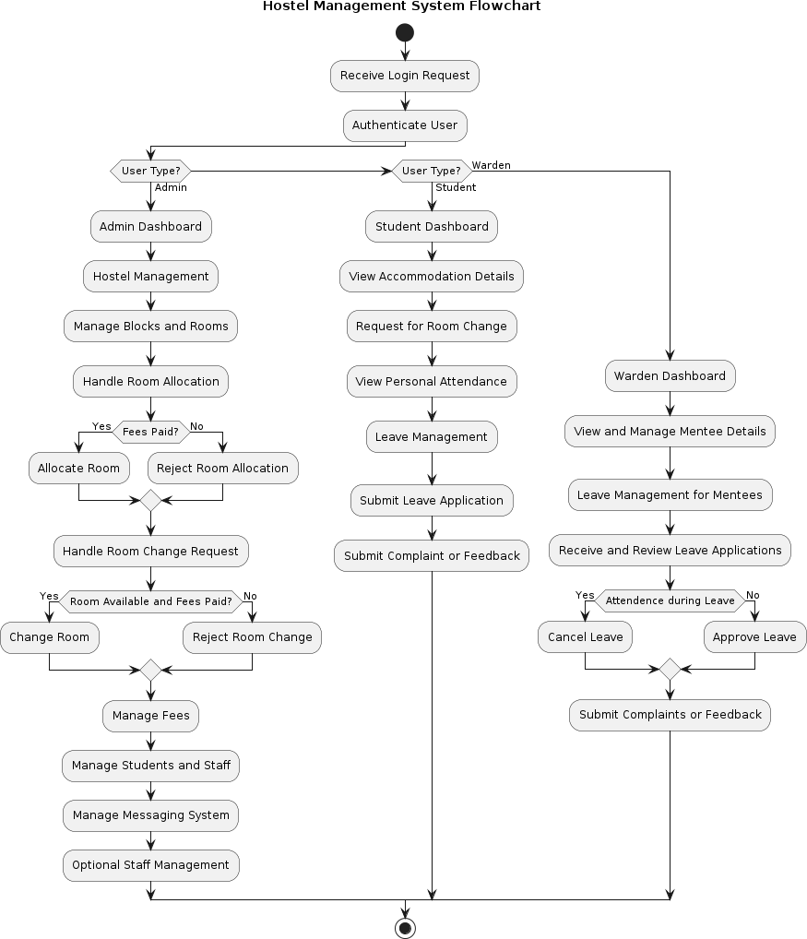

**ER DIAGRAM (DB Design):**

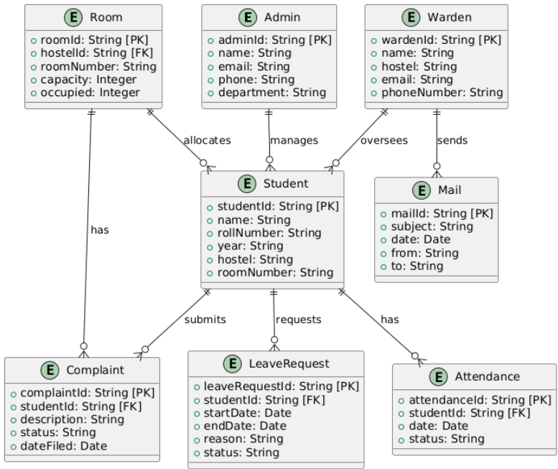

# PROTOTYPES:

**LOGIN: USER TYPE:**

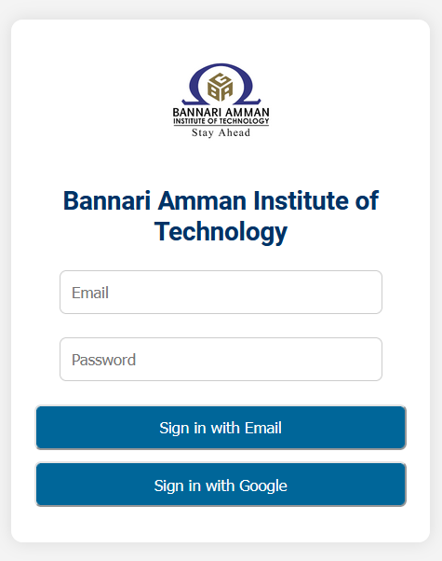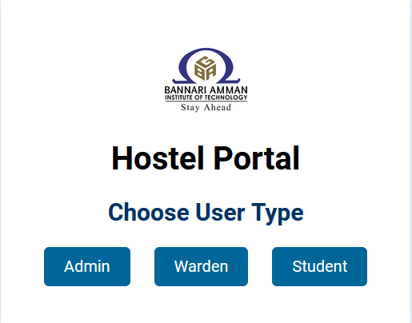

# ADMIN PORTAL:

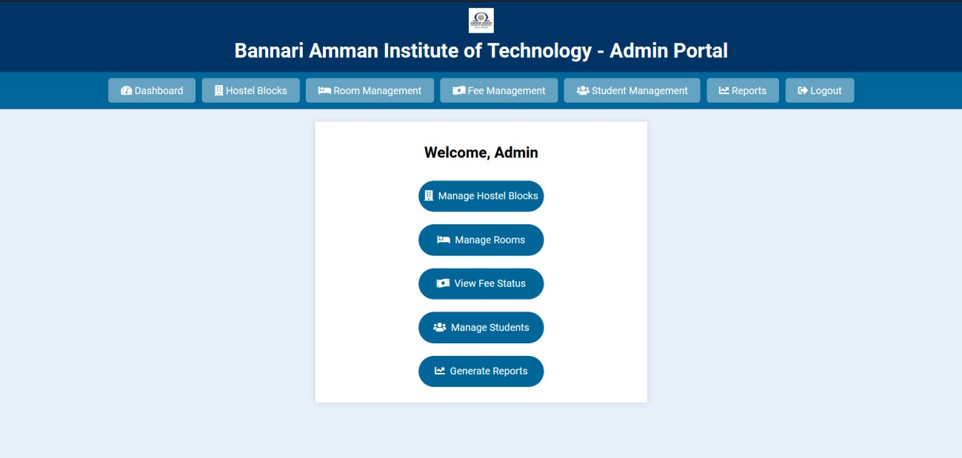

**STUDENT PORTAL:**

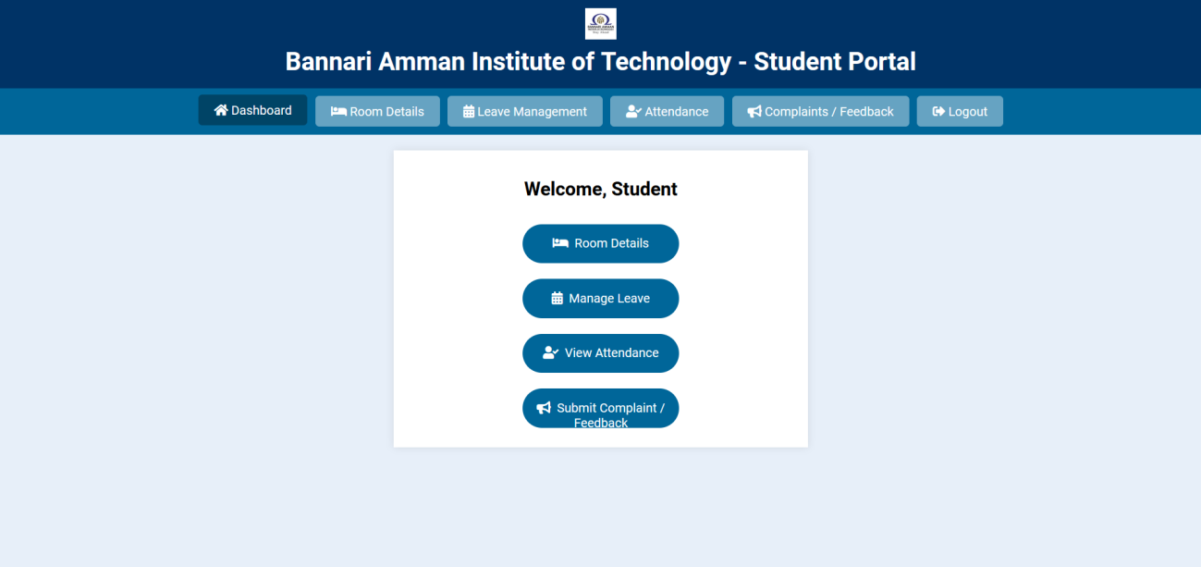

# WARDEN PORTAL:

